|  |  |
| --- | --- |
| **NAME:** | LASHYA P |
| **ROLL NO:** | 18BCS045 |
| **COURSE:** | INTERNET AND WEB PROGRAMMING |
| **CODE:** | **PROTO21 U18CSI6201** |
| **DATE:** | 03-11-2021 |

**EXPERIMENT 1**

**APPLY 3 TYPES OF CSS TO A HTML PAGE (RESUME)**

**AIM:**

To develop a HTML web page that contains the resume and apply style specification using CSS.

**PROCEDURE:**

1. FIRST , WRITE THE CODE USING HTML IN VS CODE/ NOTEPAD any text editor.
2. SAVE IT AS .html FILE ., SAVE THE CSS FILE AS .css
3. RUN THE CODE ON A BROWSER

**SOURCE CODE:**

Html Code

<!DOCTYPE html>

<html lang="en">

<head>

    <meta charset="UTF-8">

    <meta http-equiv="X-UA-Compatible" content="IE=edge">

    <meta name="viewport" content="width=device-width, initial-scale=1.0">

    <title>CSS</title>

    <link rel="stylesheet" href="cssex.css">

    <style>

    body{

        font-family: sans-serif;

    }

    h1{

        font-style: italic;

        font-weight: 600;

        font-variant: small-caps;

        font-family: sans-serif;

        color: brown;

        margin-left: 500px;

      }

     span{

         color:blueviolet;

         font-weight: bold;

     }

     .head{

        font-variant: small-caps;

        color: black;

        font-weight: 600;

        font-family: sans-serif;

     }

    </style>

</head>

<body>

    <h1> Lashya Ponkumar -Resume </h1>

    <p class="head">About Me</p>

    <p>A curious engineer in progress to <span>learn new things and to innovate them.</span>

        Naturally, I am excited to work as a team.

         I can <span>quickly adapt to circumvent</span> and I consider that's the greatest of all strength.

         I am a self motivating guy who is a <span>good team player </span> and punctual with time management. </p>

<p class="head">Skills</p>

</b>

<ul>

  <li>UI/UX</li>

  <li>Web Development</li>

  <li>Data Analyst</li>

  <li>Machine Learning</li>

</ul>

<p class="head">Educational Qualifications</p>

    </b>

    <table>

        <tr id="heading">

            <td>Qualification</td>

            <td>School</td>

            <td>Percentage</td>

            <td>Year</td>

        </tr>

        <tr>

            <td>10</td>

            <td><a href="https://www.facebook.com/pages/category/School/Indian-matriculation-schoolHarur-198823593582064/">IMS</a></td>

            <td>94.4</td>

            <td>2016</td>

        </tr>

        <tr>

            <td>12</td>

            <td><a href="https://www.facebook.com/pages/category/School/Indian-matriculation-schoolHarur-198823593582064/">IMS</a></td>

            <td>92.6</td>

            <td>2018</td>

        </tr>

        <tr>

            <td>BE</td>

            <td><a href="https://www.kct.ac.in">KCT</a></td>

            <td>8.9</td>

            <td>2022</td>

        </tr>

    </table>

<p class="head">Experience</p>

</b>

<dl>

    <b><dt class="topic">Technophile Traine</dt></b>

      <dd>Acquire knowledge from various fields over the period, which helps me to improve thinking skills. One of the enthusiastic person in our team.Technophile training is the process where students are taught with engineering fundamental concepts, self development skills and to create innovative products.</dd>

    <b><dt class="topic">Innovation Engineer Traine</dt> </b>

      <dd>20-week program where we as a team collaborated with startups for solving real-world problems by developing a minimum usable prototype. We are guided by Forge's program leads and startup representatives to solve the problem </dd>

</dl>

<p class="head">Interests</p>

    </b>

    <ul>

      <li style = "font-style:italic">Drawing</li>

      <li style = "font-style:italic">Gardening</li>

      <li style = "font-style:italic">Design</li>

      <li style = "font-style:italic">Programming</li>

      <li style = "font-style:italic">Computer Science</li>

    </ul>

    <p class="head">Leadership Roles</p>

</b>

<div class="leader">

<ul>

    <li>Yoga Trainer for AGAM |2019-2020(A Platform for Yoga and Personal Development) </li>

    <li>Team Lead at Career Guidance Forum of Young Ones| August 2020 - August 2021</li>

    <li>One of the organizers serves as a mentor for this Hackathon - Servathon.</li>

    <li>Joint Treasurer for Rotaract Club of KCT. | June 2020 - June 2021</li>

    <li> Brigade Leader in Ignite'20. One of the Organizers of State Level Yoga Championship.</li>

</ul>

</div>

</body>

</html>

**CSS PAGE:**

.topic{

    font-size: medium;

    font-family: 'Times New Roman';

    color: orangered;

}

table {

    border: 1px solid black;

}

td {

    padding: 2px;

    border: 1px solid black;

}

.leader{

    color: tomato;

}

**OUTPUT:**

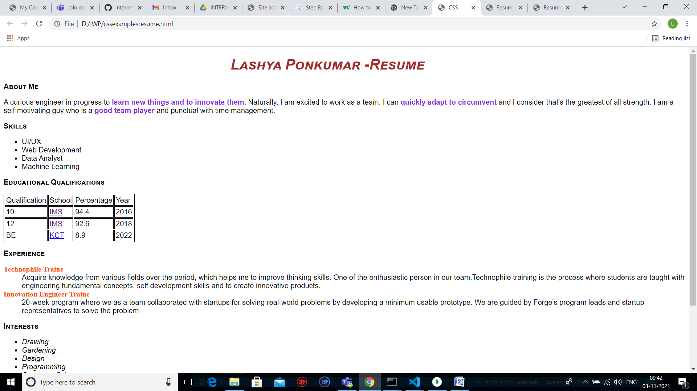

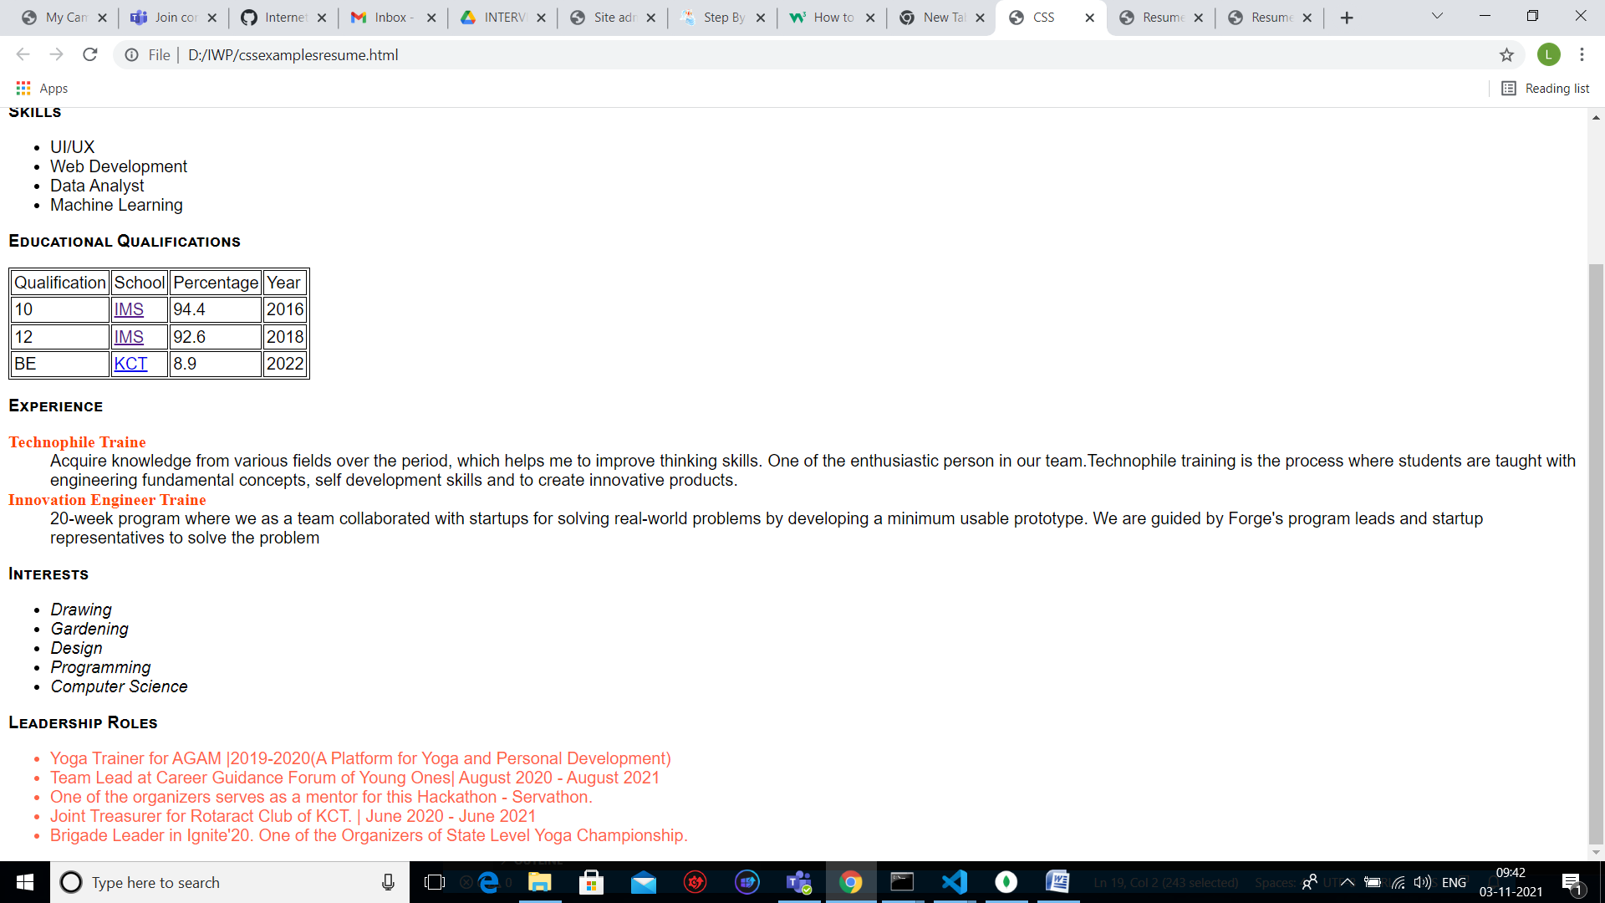

**RESULT:**

The HTML web page for the resume is successfully created and styles are applied to the web page.

[github link](https://github.com/Lashya13/Internet-and-web-programming/blob/main/resume.html)